Advanced Topics in DBMS
What is a Parallel Database in DBMS?
A parallel database is a type of database system designed to improve performance and scalability by dividing work across multiple processors, disks, or machines. Instead of processing queries on a single CPU, it executes operations simultaneously (in parallel).

Why Use Parallel Databases?
Parallel databases are mainly used to:
- Handle large volumes of data
- Improve query performance
- Support data warehousing and analytics
- Increase system scalability

Distributed Database System
A Distributed Database System (DDBS) is a collection of multiple databases spread across different physical locations, connected via a network. Unlike a centralized system, where all data is stored in one place, a distributed system manages data across various sites while making it appear as a single database to users.

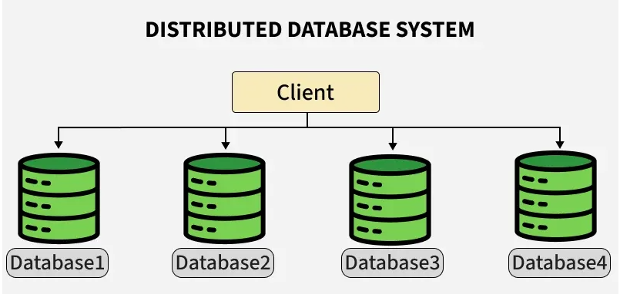

Multimedia Database in DBMS
A Multimedia Database (MMDB) is a database system designed to store, manage, and retrieve multimedia data such as images, audio, video, graphics, and animations along with traditional text data.
Unlike regular databases (which store structured data like numbers and text), multimedia databases handle large, complex, and unstructured data formats.

Types of Multimedia Data
- Text – documents, articles
- Images – photos, graphics
- Audio – music, voice recordings
- Video – movies, clips
- Animation – moving graphics
Mobile Database in DBMS
A Mobile Database is a database that supports mobile users and mobile devices (like smartphones, tablets, laptops) to access and manage data over a wireless network.

Key Components of Mobile Database System
- Mobile Devices
Smartphones, tablets, laptops used by users.
- Wireless Network
Wi-Fi, 4G/5G, or other mobile networks for communication.
- Server / Central Database
Stores the main database and processes requests.
Example mobile database technologies:
- SQLite (used in mobile apps)
- Firebase Realtime Database
- Oracle Database Lite

Web Database in DBMS
A Web Database is a database that is accessible through a web application using the internet or intranet.
It allows users to interact with the database using a web browser.
In simple terms, it connects:
User (Browser) → Web Server → Database Server
User (Web Browser)
|
Internet
|
Web Server
(Application Logic)
|
Database Server
(DBMS + Data)

How It Works:
- User sends request through browser.
- Web server processes request using server-side scripts.
- Server communicates with database.
- Database sends data back to web server.
- Web server displays result to user.

Data Warehouse in DBMS:
A Data Warehouse (DW) is a centralized repository that stores large amounts of historical data collected from multiple sources to support reporting, analysis, and decision-making.

Characteristics of Data Warehouse
- Subject-Oriented
Organized around subjects like sales, customers, products.
- Integrated
Data is collected from multiple sources and unified.
- Time-Variant
Stores historical data over years.
- Non-Volatile
Data is not frequently changed or deleted.
Big Data in DBMS
Big Data refers to extremely large and complex datasets that cannot be efficiently processed using traditional DBMS systems.

5 V’s of Big Data
- Volume – Huge amount of data (TB, PB, EB).
- Velocity – Data generated at high speed.
- Variety – Different types of data (text, video, images).
- Veracity – Data quality and accuracy.
- Value – Useful insights extracted from data.
NoSQL in DBMS
NoSQL stands for “Not Only SQL.”
It is a type of database designed to handle large-scale, distributed, and unstructured or semi-structured data.

Why NoSQL is Used?
- To handle Big Data
- For high-speed data processing
- For flexible data models
- For horizontal scalability

Difference between OLTP and OLAP
